Computer Language Coding Concepts

Target Classes in a Diagram
The concept of target classes is explained in the article Target Classes. This article only explains their expression in a diagram.

To find the target class, you first follow all the object redirections, then one class redirections, then all the object redirections and there it ends.

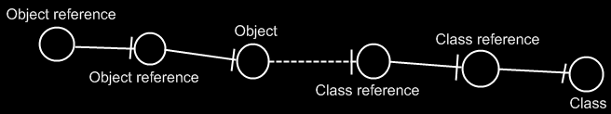

If the class has a class as well, this does not redirect the original object’s class, because the second class is another class object, that the first class is just based on. An object redirection is just a much tighter bond, than a class redirection.

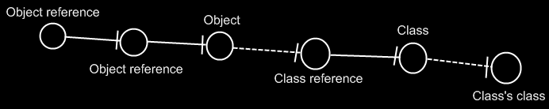

The target class of the first object reference is the symbol Class, not the symbol Class’s class. The same counts for the diagram below.

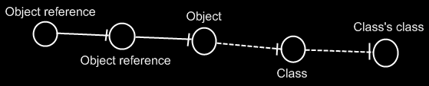

See also: Target Classes

Author & Copyright: Jan-Joost van Zon Date: May 29, 2008 – August 17, 2008 Location: Oosterhout, The Netherlands Status: Finished

